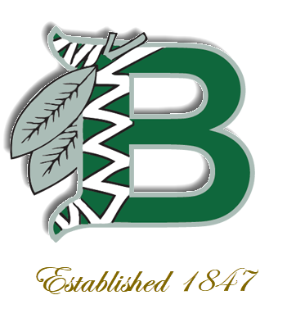

The

NMS Library Buzz

**Volume 1- Issue 1 – September 2020**

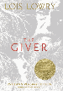



…And more

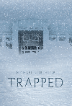

Welcome to our school library! We are very excited to share this school year with you. We know this year is different from others but be certain that your library will always be here to help you.

Ms. Griffing

Check out our collection of e-books go to [www.DestinyDiscover.com](http://www.DestinyDiscover.com)



Celebrate September

* Library Card Sign-up Month
* National Hispanic Heritage Month (Sept. 15- Oct. 15)
* National Honey Month
* National Piano Month
* National Grandparents Day (Sept. 13)
* International Talk Like a Pirate Day (Sept. 19)
* International Day of Peace (Sept. 21)
* Autumn Begins! (Sept. 22)
* National Punctuation Day (Sept. 24)

Welcome to the Library Media Center

Ms. Griffing, Library Media Specialist / [kgriffin@bufsd.org](mailto:kgriffin@bufsd.org) / 631-434-2368

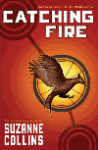

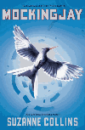

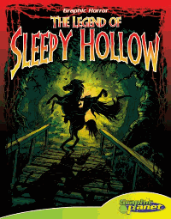

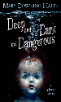

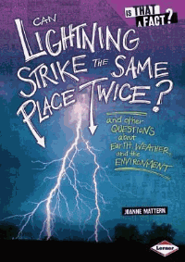



Fines

* Fines are NOT charged for overdue books
* Replacement fees ARE CHARGED for lost or damaged books.

Rules for Borrowing

* You may borrow 1 (one) book at a time.
* Returned books will be placed in “*Quarantine*” for 7 (seven) days after.
* NMS Library has a “HOLD” policy. Students may place books on hold, while they’re placed in “*Quarantine*”.

